**How To Turn Your Program Into An Executable Program (That you can market and sell)**

**STEP #1:**

* Create a program that you want to make into an executable
* Then click on “Project” and then “Publishxxxx”. NOTE: “xxxx” will be the name of your application.

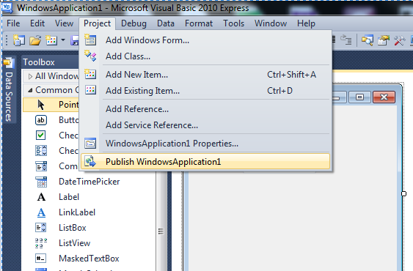

**STEP #2:**

* Specify the path to the location where you want you resulting files to be saved and click “next”

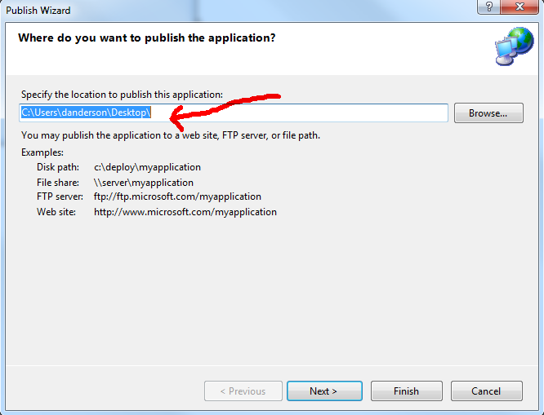

**STEP #3:**

* Choose how you want the end user to install your program. In this case we are planning on burning the installation files to a CD or DVD to sell, so we can choose that option.

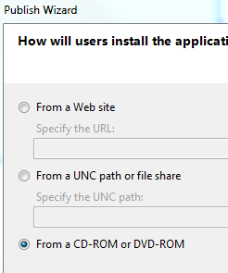

**STEP #4:**

* The next option allows you to have the program to automatically check for updates from a location you specify. In this case we will choose not to have it do that.

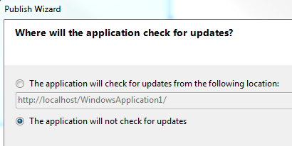

**STEP #5:**

* Now you are ready to click finish and create your files. NOTE: Double check to make sure of the location where you are saving your files.

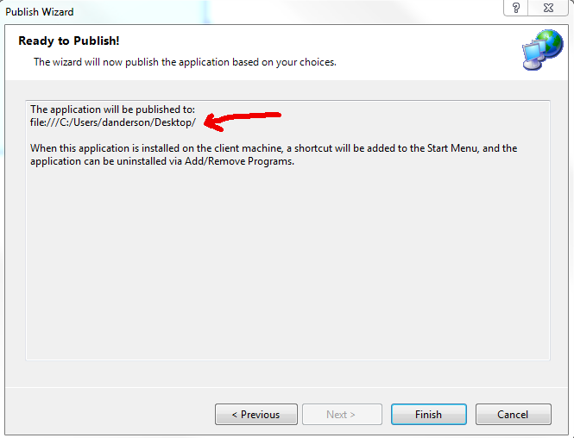

**STEP #6:**

* Now you should see three files (in this case on the desktop). These are our installation files that you would burn to a CD or whatever, and distribute. NOTE: when you click on the files to run the program it will prompt the user to install it. NOTE: If you install anything on the school computers, please make sure you uninstall it when you are done.

